**Lesson 5 Demo 7**

**Understanding Scheduling Profiles**



Steps to be followed:

1. Defining Scheduling Profiles

**Step 1: Defining Scheduling Profiles**

1. Create a config file with the following command:

**vi scheduler.conf**



1. Write the following code in the file:

***profiles:***

***- schedulerName: default-scheduler***

***plugins:***

***score:***

***disabled:***

***- name: NodeResourcesLeastAllocated***

***enabled:***

***- name: NodeResourcesLeastAllocated***

***weight: 10000***

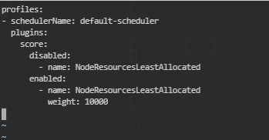

1. Write the following code to restart kubelet:

***systemctl restart kubelet***



1. Write the following code to describe the pod:

***kubectl describe pod kube-scheduler-master -n kube-system***

